Project Design Phase-II
Data Flow Diagram & User Stories

Date | 01 February 2026
Team ID | LTVIP2026TMIDS60803
Project Name | Optimizing User, Group, and Role Management with Access Control and Workflows
Maximum Marks | 4 Marks

Data Flow Diagrams:
A Data Flow Diagram (DFD) is a traditional visual representation of the information flows within a system. A neat and clear DFD can depict the right amount of the system requirement graphically. It shows how data enters and leaves the system, what changes the information, and where data is stored.
DFD – Level 0 (Context Diagram)
DFD – Level 1 (Detailed System Diagram)

Example: (Simplified)

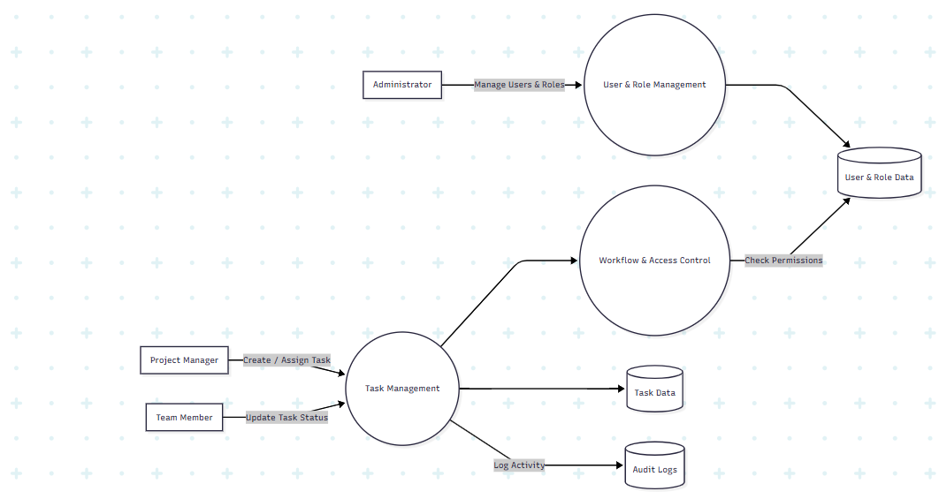
User Stories

Project Manager (Alice)
User Type | Functional Requirement (Epic) | User Story Number | User Story / Task | Acceptance Criteria | Priority | Release
Project Manager | Login | US-1 | As a Project Manager, I can log into the system securely | Dashboard loads after authentication | High | Sprint-1
Project Manager | Task Management | US-2 | As a Project Manager, I can create new tasks | Task is saved in Task Table | High | Sprint-1
Project Manager | Task Assignment | US-3 | As a Project Manager, I can assign tasks to a team member | Task assigned successfully | High | Sprint-1
Project Manager | Task Monitoring | US-4 | As a Project Manager, I can view task progress | Status updates visible | High | Sprint-2
Project Manager | Close Task | US-5 | As a Project Manager, I can close completed tasks | Task marked as Completed | Medium | Sprint-2

Team Member (Bob)
User Type | Functional Requirement (Epic) | User Story Number | User Story / Task | Acceptance Criteria | Priority | Release
Team Member | Login | US-6 | As a Team Member, I can log into the system | Assigned tasks are visible | High | Sprint-1
Team Member | View Task | US-7 | As a Team Member, I can view tasks assigned to me | Only assigned tasks are displayed | High | Sprint-1
Team Member | Update Task | US-8 | As a Team Member, I can update task status | Status changes saved | High | Sprint-1
Team Member | Comment on Task | US-9 | As a Team Member, I can add comments to tasks | Comments stored in task record | Medium | Sprint-2

Administrator
User Type | Functional Requirement (Epic) | User Story Number | User Story / Task | Acceptance Criteria | Priority | Release
Administrator | User Management | US-10 | As an Admin, I can create and manage users | Users saved in User Table | High | Sprint-1
Administrator | Role Management | US-11 | As an Admin, I can create and assign roles | Roles linked to users | High | Sprint-1
Administrator | Group Management | US-12 | As an Admin, I can create and manage groups | Groups updated successfully | Medium | Sprint-2
Administrator | Access Control | US-13 | As an Admin, I can define ACL rules | Unauthorized access is restricted | High | Sprint-2
Administrator | Audit Reports | US-14 | As an Admin, I can generate activity reports | Reports downloadable | Medium | Sprint-2

